**IBM ASSIGNMENT-I**

|  |  |
| --- | --- |
| Assignment Date | 16 September 2022 |
| Student Name | Sowmiya P |
| Student Roll Number | 922519205110 |
| Maximum Marks | 4 Marks |

**Question**

To design a circuit using PIR sensor, Temperature sensor and Piezo alarm and to perform the following operations:

1. Alarm should sound in one manner if the temperature is above “60 C”.
2. Alarm should sound with another frequency if motion is detected using PIR sensor.

**Circuit:**

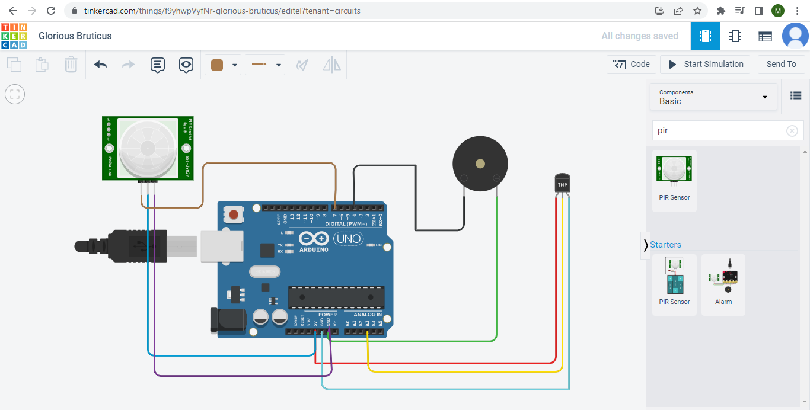

**Code:**

void setup()

{

Serial.begin(9600);

pinMode(4,OUTPUT);

pinMode(7,INPUT);

}

void loop()

{

int a=digitalRead(7);

double td=analogRead(A3);

double n=td/1024;

double volt=n*5;

double offset=volt-0.5;

double temperature=offset*100;

Serial.print("Temperature Detected: ");

Serial.println(temperature);

if(a==0){

Serial.println("No Motion Detected");

}

if(a==1){

Serial.println("Motion Detected");

tone(4,100,1000);

}

if(temperature>60){

tone(4,400,1000);

}

}

**Output:**

